

SRM UNIVERSITY ANDHRA PRADESH

**Introduction to programming using C project synopsis on**

“Airline reservation system”

Submitted in partial fulfilment further award of the degree in

BACHELOR OF TECHNOLOGY

IN

COMPUTER SCIENCE AND ENGINEERING

submitted by:-

Rohit Kamal Kumar Yenduri AP21110010303

Deekshitha Chirumamilla AP21110010304

Shreyan Dasari AP21110010305

**Under the guidance of Ms. Snehal K**

**Project Mentor**

***CONTENTS***

Chapter 1) Aim/Objective

Chapter 2) Technologies Used: -

2.1) Hardware Requirement

2.2) Software Requirement

Chapter 3) Abstract

Chapter 4) Introduction  
Chapter 5) Algorithm  
Chapter 6) Sample Input/Output (screenshot)

Chapter 7) End User  
Chapter 8) Conclusion

**CHAPTER 1**

***Aim/Objective***

The main objective of the project is to develop online Banking system for online. In present some of airline reservation is done manually. User has to visit airport to book ticket. Some of users may find some difficult to go to airport and get their ticket reserved so in this airport reservation system, we will automate all the booking process. In our airline reservation system user can check available seats, class. In this Software you can keep record of tickets booked. The main purpose of developing airline reservation system is to design an application, which could store data and provide an interface ticket related details with 100% accuracy. This airline reservation system also allows user to book multiple tickets, cancel ticket. Using this system user can also search any individual seat in few seconds. Our system also provides security check to reduce fraud. The system will check the user’s existence in the database and provide the set of services with respect to the role of the user.

And some other objectives of the system are-

✓ To reduce paperwork.  
✓ Reduced operational time.  
✓ Increased accuracy and reliability.

✓ Fast Process.  
✓ Increased operational efficiency. ✓ Data security.

**CHAPTER 2**

***TECHNOLOGIES USED***

**System Requirement Specification (Software and hardware requirement)**

**Software Requirements:**

Language used: C  
Operating System: Windows 7 or above

**Hardware Requirements:**

Processor: i3 10th gen  
RAM: 2GB or above  
Hard Disk Drive: 256GB or above.

**CHAPTER 3**

***ABSTRACT***

The Airline Reservation System is software developed to avoid manual problems and to make it user-friendly. So it can carry out operations in a smooth and effective manner without any errors. It is also a reliable and fast management system. It also contains better utilization of resources. The aim is to automate the manual system with the computerized equipment and computer software by full-filling their requirements. The airline reservation in C source code is a console application that can let you book seat in flight. User need to enter passport number, name, email, destination, seat number to book ticket. Here user can also cancel the ticket and user can also see the records.

**CHAPTER 4**

***INTRODUCTION***

When user entered password then the database will show some options, they are Please enter your choice from below (1-4):

1. Reservation  
2. Cancel  
3. DISPLAY RECORDS  
4. EXIT **[and some other options]** Feel free to contact

Then user needs to enter his/her choice from the above options. After selecting the option, he/she need to enter the respective details and the operation will be performed successfully.

**CHAPTER 5**

***ALGORITHM***

**STEP-1**: Start  
**STEP-2:** DISPLAY welcome to AIRLANE RESERVATION SYSTEM **STEP-3:** select choice from 1-4  
**STEP-4:** if choice is 1 then

**STEP-4.1:** write passport number **STEP-4.2**: write name **STEP-4.3:** write mail address **STEP-4.4:** write destination

**STEP-5:** display seat booking successful and your seat number is **STEP-6:** if choice is 2 then

**STEP-6.1:** write passport number to delete record **STEP-7:** booking has been deleted  
**STEP-8:** if choice is 3 then

**STEP-8.1:** display existing record details **STEP-9:** if choice is 4 then

**STEP-9.1:** write Details have been saved to a file **STEP-10:** if choice is greater than 4 or less than 1 then

**STEP-10.1**: write SORRY INVALID CHOICE & PLEASE CHOOSE FROM 1-4 & Do not forget to choose from 1-4  
**STEP-11:** STOP

**CHAPTER 6**

***SAMPLE INPUT/OUTPUT***

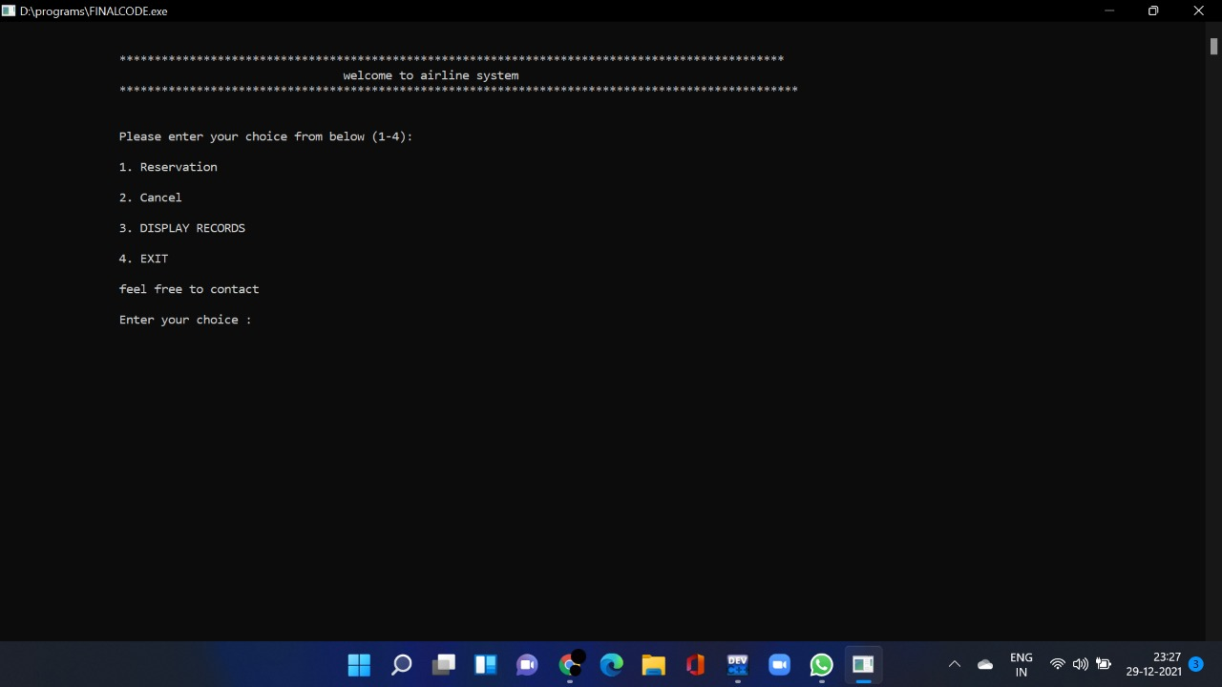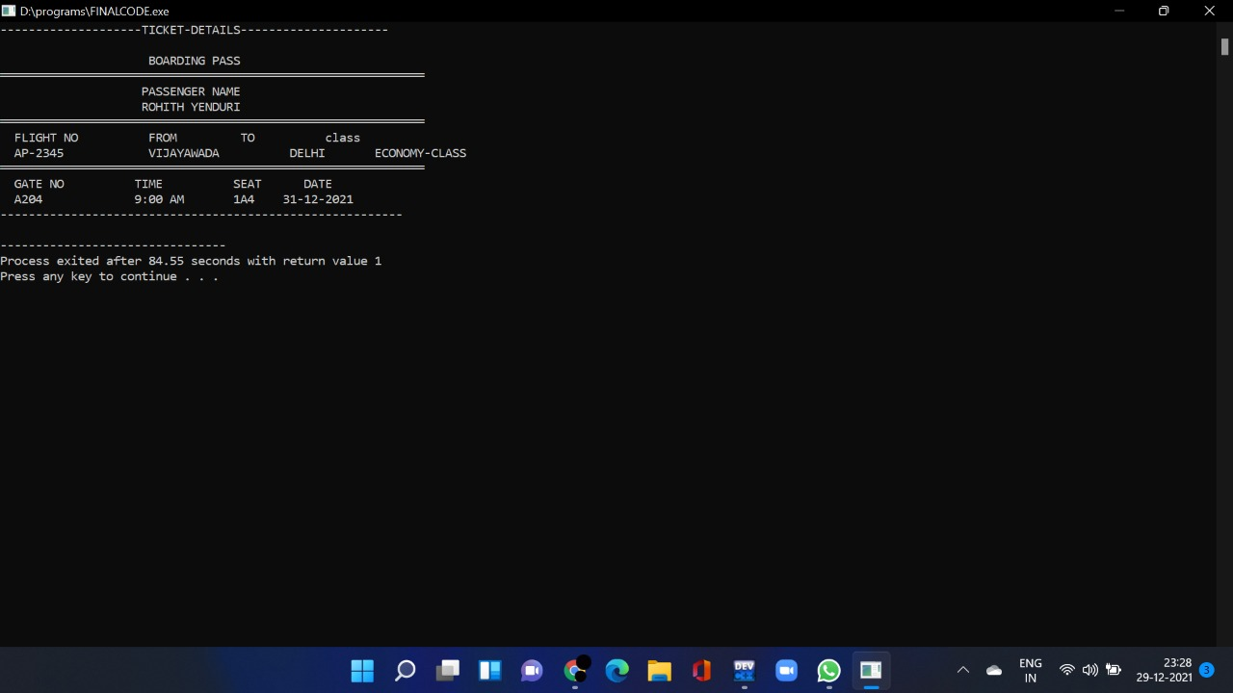

**CHAPTER 8**

***END USER***

This project makes it easy and convenient to reserve plane tickets. Instead of waiting in long lines you can now book tickets at the comfort of your home.

It also saves tons of time and you can also check all the alternate flight options with a click of a button

You will have various airlines to choose from

**CHAPTER 9**

***CONCLUSION***

I and my group have learned all the basics of c programming by doing this project.

We have learned how to use basic functions and also understood the basic logical understading behind a program.

And after doing this project we feel alot confident in our programming skills.